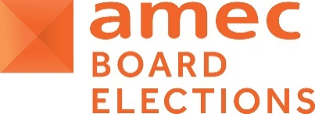
AMEC Elections to the 2022-2023 Board - Official Ballot Paper
For the Board election of One ‘Research Member Director’
The following 2 candidates have been validly nominated for election, we now ask members to complete this ballot form to vote for your 1 preferred candidate. Hyperlinks will enable you to review each candidate’s Nomination Form and Election Manifesto. ONLY Research Members can vote in this ballot.
Please cast ONE vote for your ONE preferred candidate out of the two by entering ‘x’ in the appropriate column on the grid below, forwarding the saved document via e-mail to juliewilkinson@amecorg.com
- Please complete by the deadline of THURSDAY 4 NOVEMBER 2021.
- Please validate by providing your name and the name of the company you represent below.
AMEC Research Member Company:
Name and title of representative submitting:

Candidate Name | Title & Company | Links below to view:  Nomination and Personal Statement/Manifesto | YOUR VOTE (X)  Please vote by indicating X against your 1 selected candidate
- Jon Meakin | President North America, Clarity PR | - Nomination and Election Manifesto
- Allison Spray | Managing Director Data & Analytics, Hill + Knowlton Strategies | - Nomination and Election Manifesto

IMPORTANT NOTE TO THE BALLOT PROCESS
- Please CHECK CAREFULLY that your votes have been recorded properly as mistakes cannot be rectified after the ballot closes under any circumstances.
- Each Research Member company may submit only one completed ballot paper. This is a secret ballot and is confidential to the two scrutineers.

Johna Burke Julie Wilkinson
Global Managing Director - Scrutineer Executive Assistant - Scrutineer
20 October 2021

